EXPERIMENT 1: DDL OPERATIONS ON SHOWROOM DATABASE
AIM:
- To create a showroom database and perform basic DDL operations such as CREATE, ALTER, RENAME, TRUNCATE, and DROP using MySQL.
PROCEDURE:
- Create a database named AUTOHUB_SHOWROOM.
- Select the database using the USE command.
- Create a VEHICLE table with vehicle details.
- Insert vehicle records into the table.
- Display the records using SELECT.
- Use ALTER to add a new Brand column.
- Use RENAME to rename the table.
- Use TRUNCATE to remove all records from the table.
- Use DROP to delete the table completely.
- Display the remaining tables using SHOW TABLES
OUTPUT: 1
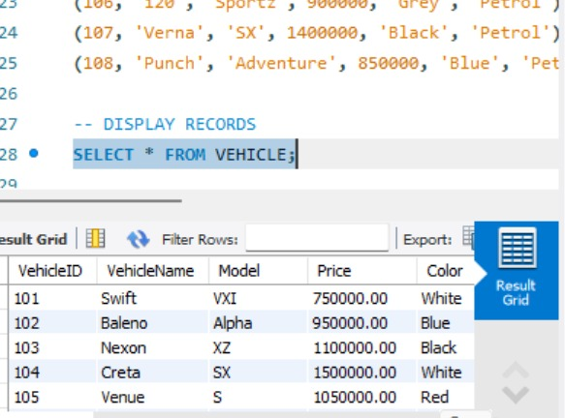

OUTPUT:2
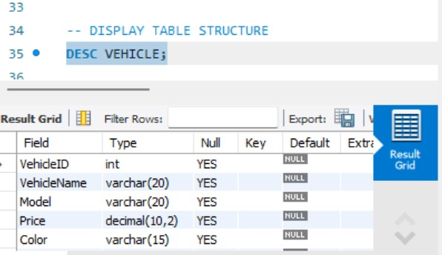

OUTPUT:3
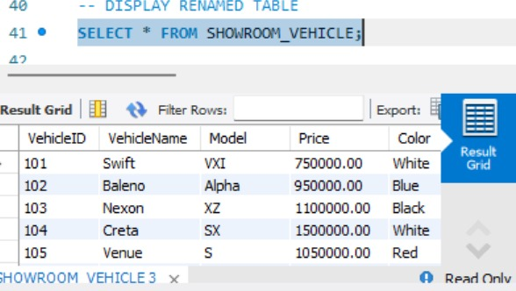

OUTPUT:4
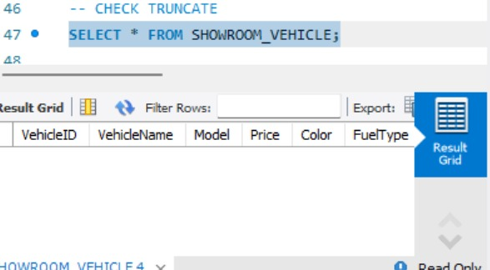

OUTPUT: 5
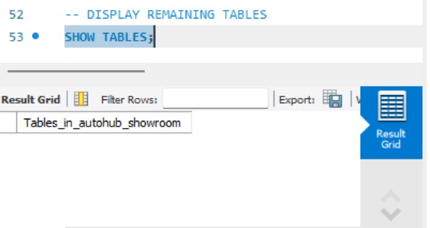

QUERY:
CREATE DATABASE AUTOHUB_SHOWROOM;
USE AUTOHUB_SHOWROOM;
-- CREATE
CREATE TABLE VEHICLE (
VehicleID INT,
VehicleName VARCHAR(20),
Model VARCHAR(20),
Price DECIMAL(10,2),
Color VARCHAR(15),
FuelType VARCHAR(10)
);
-- INSERT 8 RECORDS
INSERT INTO VEHICLE
VALUES
(101, 'Swift', 'VXI', 750000, 'White', 'Petrol'),
(102, 'Baleno', 'Alpha', 950000, 'Blue', 'Petrol'),
(103, 'Nexon', 'XZ', 1100000, 'Black', 'Diesel'),
(104, 'Creta', 'SX', 1500000, 'White', 'Diesel'),
(105, 'Venue', 'S', 1050000, 'Red', 'Petrol'),
(106, 'i20', 'Sportz', 900000, 'Grey', 'Petrol'),
(107, 'Verna', 'SX', 1400000, 'Black', 'Petrol'),
(108, 'Punch', 'Adventure', 850000, 'Blue', 'Petrol');
-- DISPLAY RECORDS
SELECT * FROM VEHICLE;
-- ALTER
ALTER TABLE VEHICLE
ADD Brand VARCHAR(20);
-- DISPLAY TABLE STRUCTURE
DESC VEHICLE;
-- RENAME
RENAME TABLE VEHICLE TO SHOWROOM_VEHICLE;
-- DISPLAY RENAMED TABLE
SELECT * FROM SHOWROOM_VEHICLE;
-- TRUNCATE
TRUNCATE TABLE SHOWROOM_VEHICLE;
-- CHECK TRUNCATE
SELECT * FROM SHOWROOM_VEHICLE;
-- DROP
DROP TABLE SHOWROOM_VEHICLE;
-- DISPLAY REMAINING TABLES
SHOW TABLES;

RESULT:
- The AutoHub Showroom database was successfully created.
- The VEHICLE table was created and records were inserted successfully.
- CREATE, ALTER, RENAME, TRUNCATE, and DROP operations were performed successfully.
- Thus, the required DDL operations were executed successfully in MySQL.

